**Artificial Neural Networks & Multilayer Perceptron**

As a second machine learning technique we decided to use Multilayer Perceptron which is one of the part of the Artificial Neural Networks. According to our dataset success rate is determined and according to football team`s result this value is specified. Thanks to this technique, we tried to estimate value of success rate by examples. This neural network technique works as a brain (nervous system) and it starts it`s process by learning by examples. Then, it tries to predict the result according to given data set. And finally, it checks the predicted result and it gives accuracy rate of technique.

Codes:

* Used Libraries

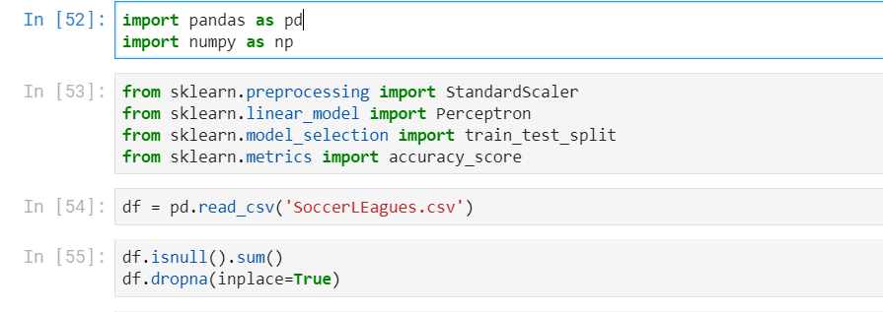



🡪Determination of Target



🡪Train_test_split and train the scalar

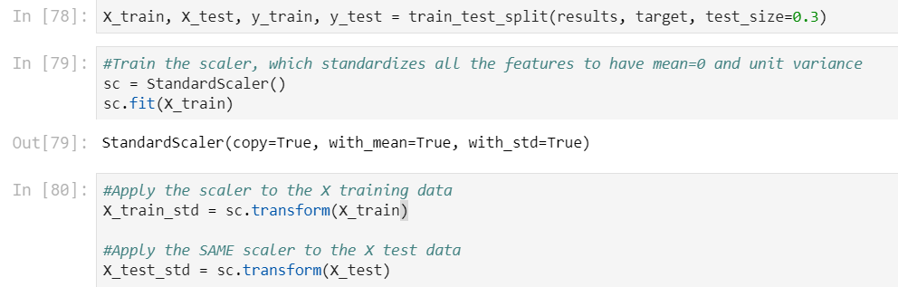🡪Creation and training of perceptron

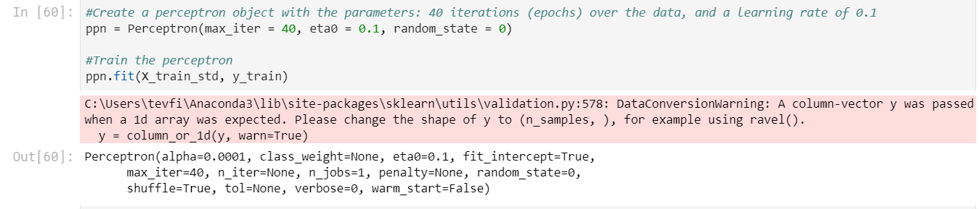🡪Apply perceptron and accuracy rate

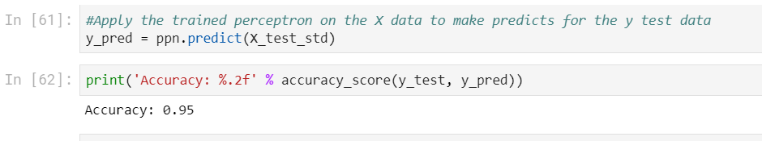**Accuracy 🡪%95.**

To get result of Multilayer Perceptron codes are shown. Multilayer Perceptron is composed of more than one perceptron.

Input Layer - Receive Signal

Output Layer – Prediction of Input Signal

🡪MLP Classifier

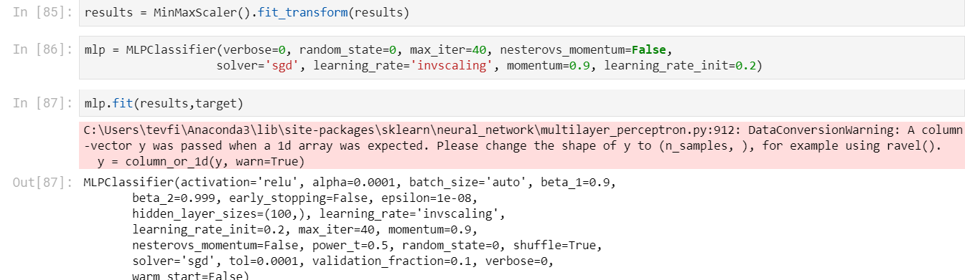

🡪Training Scores

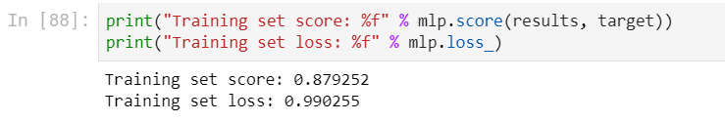

🡪Plot

